Decision correspondence
Decision: Accept with revision
Date of decision: 2025-06-02
Decision email title: Decision: Acceptable after revision
Decision email text: Manuscript: MEPS-2024-09-002/R1 RESUBMISSION- Blue mussels Mytilus edulis L. and M. trossulus Gould in sympatry: assessment of ecological niche divergence using species distribution modeling
Author(s): Vadim Khaitov (Corresponding Author), Paul Safonov (Co-author), Alisa Zaichikova (Co-author), Marina Katolikova (Co-author), Mikhail Ivanov (Co-author), Petr Strelkov (Co-author)

Editorial Office comments:
Please also address the following formatting and style points in your revision:
(i) Please add the section number for Results and Discussion.

Done. Надо ли вставить номера к благодарностям и списку литературы?
(ii) L414-417: Format the text to be similar with the rest of the manuscript.
Done
(iii) Spell out the species name at first mention in the figure/table legends.
Непонятое требование
(iv) Fig. 1: Please add lat/lon coordinates to the left and bottom of the figure (it is enough to have one panel with lat/lon on the frame).
Done (L 727)
-------------------------
Reviewer 1 report:
Review of Kaitov et al 2024/2025
The authors have an impressive dataset that yields insights into the niches of Mytilus trossulus and Mytils edulis. While the data and analysis should be published, I feel the manuscript still needs some revision to present the results in a way that is more coherent and approachable to the reader.
Line 45 – “stand behind” is an unusual phrase. Recommend they replace it.

We replaced the sentence. Now:

“Cryptic invasions often underlie sympatry (Morais & Reichard 2017).” (L. 46)
Line 60 - Recommend adding “of “ to “Both of these species..

Done
Line 76 – “New Scotland”!?!? do they mean “Nova Scotia”.

Since the province's official name remains Nova Scotia we changed this (L.77)
Lines 94-95 – Is MT more likely to settle on algae? Are they referring to juveniles or adults here?

Since in the Katolikova et al. 2016 authors worked with adult bottom mussel’s populations we changed the sentence to clarify it. We have changed the sentence for clarity. Now:
”Adult MT is more common on fucoid algae while adult ME mostly lives directly on the bottom substrates such as mud, sand, stones and gravel. However, segregation across substrates cannot fully explain the local-scale patchiness (Katolikova et al. 2016).”
Lines 179-180 – Maybe I missed it but I feel PtrosBottom and PtrosSite should be explained before they are referenced here.
This is where we introduce the terms for the first time. To clarify this, we have changed the sentence. Now:

“The proportion of morphotypes was converted to the proportion of MT (Ptros) in each sample, in pooled samples from each substrate from each site (thereafter denoted as PtrosAlgae and PtrosBottom) and in pooled samples from each site (thereafter PtrosSite)”. (L.178-180).
Lines 145-148 – Is this information relevant? Delete, move to discussion or explain relevance here.

Since the presence of ports is an important factor for the alien Mytilus species, as discussed in the introduction, we consider the description of ports as important information. In our opinion, this information should be given in this part of the work.
One of the tasks of this study is to assess the impact of ports (see Introduction). Therefore, we mention them in the Materials and Methods section and indicate them on the map. We are sure this information is relevant.
Line 298 – The allusion to Table 2 to explain that salinity is curvilinear needs additional explanation. (Because the edf = 2.4?)
We have added some information to the offer to eliminate uncertainty. Now:
“Effective degrees of freedom (edf) for DistPort and Fetch were close to one, indicating the linear dependence of Ptros on them. In contrast, the dependence on the third continuous predictor, Salinity, was curvilinear (edf > 2, Table 2).” (L.296-298)
Line 309 – “complete agreement” seems a bit overselling of how well the data fits. Qualify this a bit.

To qualify this we changed the sentence. Now:
OK
“The results of Model 2 were in complete good agreement with those of Model 1, the pattern of association was the same for all the predictors”
Lines 328-332 – These relationships need to be better explained in the Results text. The reader still must work pretty hard to make sense of these patterns.

We added some words to explain this.
“This means that maximum difference in Ptros on bottom and algae substrates was observed in the settlements where the two species are represented in equal proportions.” (L329-331)
This means that the species were strongly segregated by substrates at sites with a high ME abundance, which highly correlate with PC2, but not at sites with a high MT abundance (high correlation with PC1). (L 333-335)

This means that the strongest segregation of the two species by substrate is observed in settlements where they occur in equal proportions.

This means that the species were strongly segregated by substrates at sites with a high ME abundance, but not at sites with a high MT abundance (remember that PC1 and PC2 are proxies for ME and MT abundances respectively).
Lines 383 and 390 – I feel these sections could be clearer if the authors started each section by restating the pattern.

We have already described the patterns of association with predictors identified in our work at the beginning of section 4.1. Since the reviewers recommended that we shorten the text, we consider duplication of information unnecessary.
OK
Segregation of ME and MT by surf level (ME is more common in localities exposed to surf, while MT is more common in sheltered areas) may be due to the well-known differences in the mechanical properties of their shells and the ability to form dense aggregations.

Segregation by substrate (ME is more common on bottom substrates, while MT is more common on algal ones) may be explained by the same differences as segregation by surf level.
Line 401 – “In our opinion” is used here and elsewhere. The phrase is unnecessary and creates ambiguity. Are the patterns real or imagined? If MT is being displaced onto algae they should have the data to show it.

Research based on a correlative approach (including SDM) cannot provide a direct answer to such questions. We see some pattern and explain it by this way. Further, experimental work is needed to confirm/refute this explanation, which we are currently conducting, but this is the topic of future publications.
We agree with you, but with one caveat. In this paragraph, we are speculating in an attempt to explain a proven pattern. We would like to leave this phrase as it is. In line (511) and in line (194), we removed “in our opinion” following your recommendations.
Lines 403-408 – Connect these statements to the thesis of the paper. They seem almost irrelevant as currently presented.

We have added a sentence in order to indicate the connection these statements to the thesis of the paper.
However it my be, we have shown that substrate is an important factor in the segregation of the niches of the two mussel’s species. (L 405-406)
Line 720 –Somewhere explain the need/use of edf and ref-edf. Why are they included? (I may be asking to explain something obvious, but I feel details need to be accessible.)

This is standard summary for GAM analysis. We added in Table 2 caption some words.

We explain now edf in Table 2 caption.

Table 2. Parameters of smoothers and coefficients of parametric terms for Model 1 describing dependency of proportion of M. trossulus in mixed settlements (Ptros) on environmental predictors. Smoother’s summary: edf – effective degrees of freedom; ref.edf – reference effective degrees of freedom.
-------------------------
Reviewer 2 report:
The authors have done a nice job addressing comments from Reviewers. I have a few additional suggestions. Line numbers relate to the track changes version.
Line 61, instead of aquaculture objects use something like ‘species for aquaculture’

Done. OK. Now:
Blue mussels are powerful ecosystem engineers and important aquaculture objects species for aquaculture (Buschbaum et al. 2009, Gosling 2021). (L 57-58)
Line 69, since THE Pliocene
Done (L 65)
Corrected
Line 91, replace pattern with driver

Done (L 86)
Corrected
Line 416, could more concrete information be provided for what inconclusive means? Is it that MT and ME had differential responses? Is it that salinity sometimes affected both species but not always? Do the authors mean the ecophysiological responses of MT and ME to salinity can be context-dependent?

Yes, word “inconclusive” has many connatations. Writing the sentence we supposed scarcity of direct ecophysiological data. We changed the sentence. Now:

Comparative experimental ecophysiological data on MT and ME elsewhere are inconclusive scarce (Gardner & Thompson 2001, Qiu et al. 2002, Sokolova et al. 2024)

Changed for "contradictory"
Line 474, I think the wording here is off. The authors might mean “Our model was able to successfully classify sites into ME- and MT-dominated ones….

No, we meant to say that our model demonstrates high accuracy in sample classification. Within the ROC analysis framework, an AUC of 0.85 is considered indicative of strong model performance. (see for example https://www.evidentlyai.com/classification-metrics/explain-roc-curve).

К чему этот комментарий – к какому абзацу?
Line 481, the worst what? The wording here is off

Thanks! We changed this text. Now: “The model's predictive performance for the Barents Sea data (AUC ≈ 0.7), while formally acceptable, was comparatively lower than in other regions. This may be attributed to the following factors.” (L. 419-422)

The model's predictive performance for the Barents Sea data (AUC ≈ 0.7), while formally acceptable, was lower than for the White Sea.
Line 489, variation of what? Values?
Thanks! We changed text. Now: The fourth reason could be a narrow variation in values of DistPort, DistRiver, and Fetch in the small Tyuva Inlet in comparison with the Kandalaksha Bay. (L 428-430)
-------------------------
Reviewer 3 report:
Thank you to the authors for their detailed response to the comments. However, I remain concerned about the revised model (Model 2), which uses a Gaussian distribution. This choice implicitly assumes normality and homoscedasticity of the residuals—assumptions that have not been clearly demonstrated. At minimum, a diagnostic check such as a QQ plot of the residuals and residuals vs linear predictor plots should be provided to support this modeling decision.
Moreover, the use of a normal distribution to model count or abundance data is generally inappropriate, as such data are typically non-negative integers and often exhibit skewness or overdispersion. Distributions such as the Poisson or negative binomial are more suitable and widely accepted for this type of response variable.

Вадим, ни я ни Наташа смыла дискуссии не поймут, так что отключи пьяный deepl и сам отредактируй

You rightly point out the issues associated with using Gaussian-based models for count data. However, prior to model construction, we log-transformed the data (see Section 2.4.2, lines 246–247), which circumvented the problems you described. Our oversight was in labeling Figure 2 as showing the 'Dependency of E- and T-morphotype abundances' in the previous caption. In the revised version, we have clarified this as “Dependency of E- and T-morphotype log-transformed abundances.” (L 747) Now we also point it in the legend in Figure 2.

Yes, we could model the raw (untransformed) data using more complex approaches like negative binomial regression. However, our statistical framework was already sufficiently intricate, and we opted for the conventional path of data transformation.

We did, of course, validate Model 2 by examining residual plots. That said, we felt including these in the main text or supplementary materials would introduce unnecessary difficulty for readers. Per your request, we have attached the residual diagnostics to this response letter, supplemented with an analysis using the DHARMa package—renowned for its meticulousness.

Чем нести бессвязную хуйню, приведи здесь картинку и встать в основной текст короткое предложение что «были валидейтед» и все заебись.

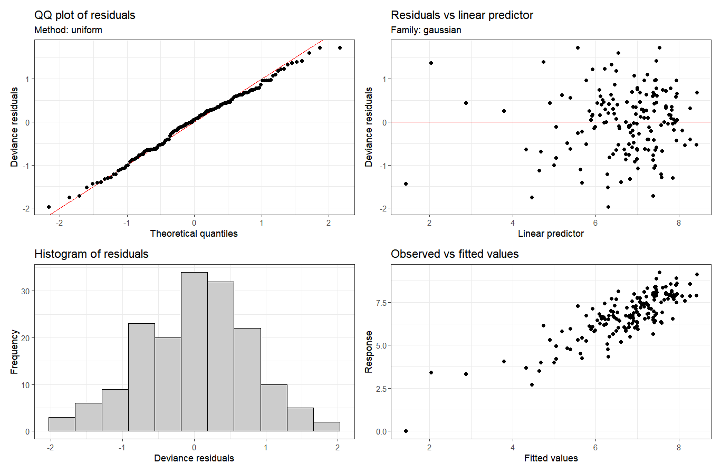
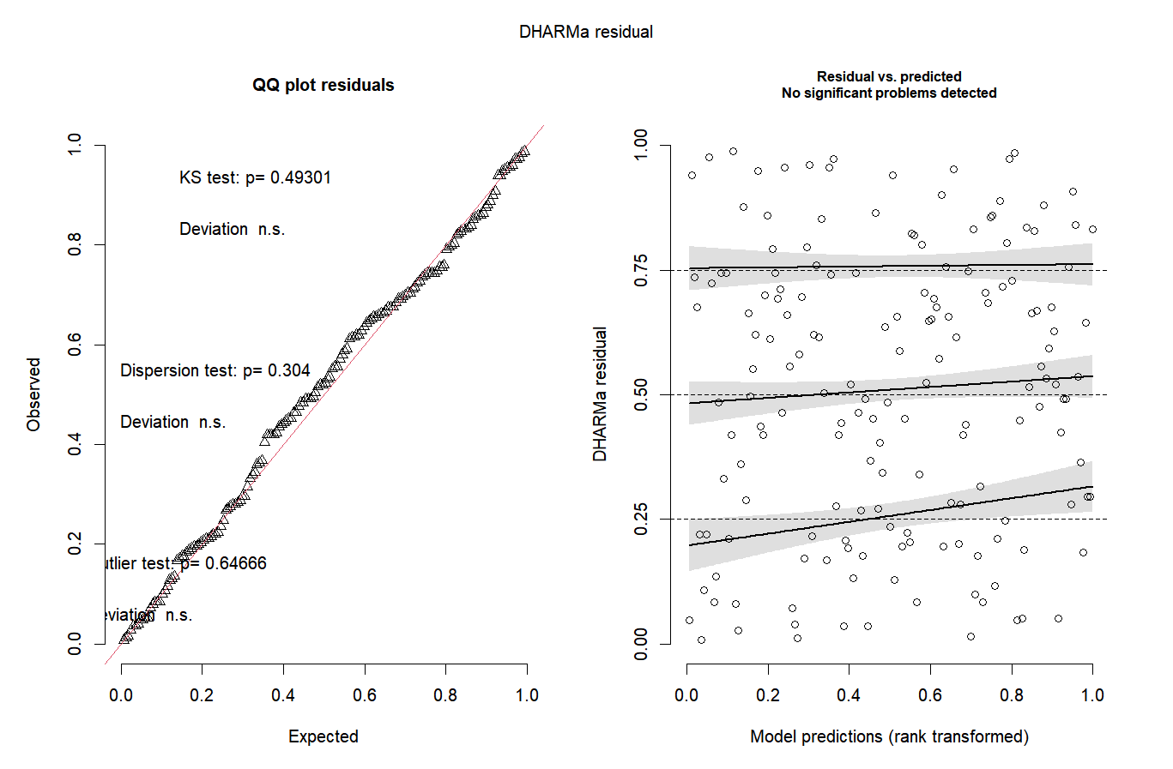

Lastly, it is surprising that the factor “substrate” is no longer included in Model 2. As noted by the authors in their response, abundance data were collected using different methods depending on the substrate type. This raises concerns about comparability between algal and bare-bottom communities. Including substrate as a random effect could help account for variation introduced by differing sampling approaches and improve the robustness of the model.
As we mentioned in our previous letter, we couldn't separate the natural differences in settlement organization between algae and sediment from the methodological differences in sampling (these methodological differences were unavoidable due to the distinct spatial geometries of the two substrate types). Thus including substrate as a fixed effect in Model 2 would be incorrect.

We believe including "Substrate" as a random effect would also be inappropriate for these reasons:

- The "Substrate" factor is inherently fixed effect - it encompasses all possible substrate types in our study (Algae vs Bottom). Random effects imply the existence of some unmeasured factor’ levels not present in our data.
- Had we treated “Substrate” as a random effect, we would only have been able to estimate its associated variance from two levels, which is considered insufficient for random effects - these typically require more than five levels to be reliably estimated (see Bolker et al., 2009, 'Generalized linear mixed models: a practical guide for ecology and evolution').

In Model 2, we averaged the abundances of T- and E-morphotypes for each site across the 6 replicate samples (see Line 246). We then log-transformed these average values before modeling and thus avoid problems described above.

Ultimately, our goal was modeling ecological niches - not absolute abundance, which fluctuates due to numerous minor factors (e.g., post-storm declines, age effects of fucoid algae, etc.). While Model 2 omits many such factors (including substrate), it demonstrates relationships with other predictors remarkably consistent with Model 1.

Один абзац с двумя предложениями, первое начинается с we disagree
-------------------------

